**Experiment No.:**

**Aim :-** Android life cycle

**CO1:** Design and develop user interfaces for mobile apps using basic building blocks, UI components and application structure using Emulator

**Procedure**

<?xml version="1.0" encoding="utf-8"?>  
<androidx.constraintlayout.widget.ConstraintLayout xmlns:android="http://schemas.android.com/apk/res/android"  
 xmlns:app="http://schemas.android.com/apk/res-auto"  
 xmlns:tools="http://schemas.android.com/tools"  
 android:layout_width="match_parent"  
 android:layout_height="match_parent"  
 tools:context=".MainActivity">  
  
 <TextView  
 android:layout_width="wrap_content"  
 android:layout_height="wrap_content"  
 android:text="Hello World!"  
 app:layout_constraintBottom_toBottomOf="parent"  
 app:layout_constraintEnd_toEndOf="parent"  
 app:layout_constraintStart_toStartOf="parent"  
 app:layout_constraintTop_toTopOf="parent" />  
  
</androidx.constraintlayout.widget.ConstraintLayout>

package com.solobin.facebook;  
  
import androidx.appcompat.app.AppCompatActivity;  
  
import android.os.Bundle;  
import android.util.Log;  
public class MainActivity extends AppCompatActivity {  
  
 @Override  
 protected void onCreate(Bundle savedInstanceState) {  
 super.onCreate(savedInstanceState);  
 setContentView(R.layout.activity_main);  
 Log.d("lifecycle","onCreate invoked");  
 }  
 @Override  
 protected void onStart() {  
 super.onStart();  
 Log.d("lifecycle","onStart invoked");  
 }  
 @Override  
 protected void onResume() {  
 super.onResume();  
 Log.d("lifecycle","onResume invoked");  
 }  
 @Override  
 protected void onPause() {  
 super.onPause();  
 Log.d("lifecycle","onPause invoked");  
 }  
 @Override  
 protected void onStop() {  
 super.onStop();  
 Log.d("lifecycle","onStop invoked");  
 }  
 @Override  
 protected void onRestart() {  
 super.onRestart();  
 Log.d("lifecycle","onRestart invoked");  
 }  
 @Override  
 protected void onDestroy() {  
 super.onDestroy();  
 Log.d("lifecycle","onDestroy invoked");  
 }  
}

**Output Screenshot**

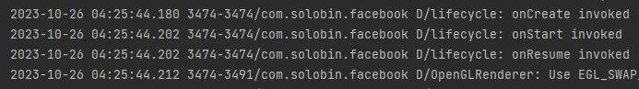

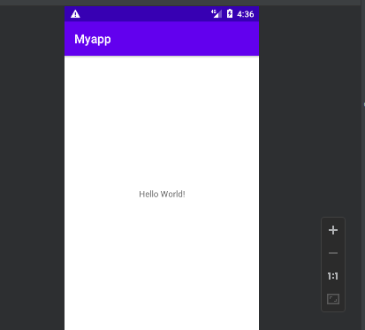

**Result**

The program was executed and the result was successfully obtained. Thus CO1 was obtained.

**Experiment No.:**

**Aim :-** Android life cycle

**CO1:** Design and develop user interfaces for mobile apps using basic building blocks, UI components and application structure using Emulator

**Procedure**

**Output Screenshot**

**Result**

The program was executed and the result was successfully obtained. Thus CO1 was obtained.